PROJECT REPORT

*Submitted*

*In partial fulfillment*

*For the award of the Industrial Training*

In Department of Computer Science & Engineering

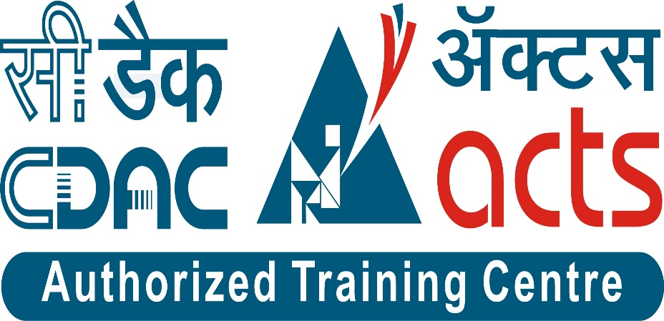

Supervisor: Submitted by:

Ms. Prajakta Patil Anshul Mehta

Course-Coordinator Ayan Talesara

C-DAC ATC NETCOM. Ankit Kelwa

CANDIDATE’S DECLARATION

I hereby declare that the work, which is being presented in the training report, entitled “JAVA APPLICATIONS” in partial fulfillment for the award of certificate to Ms. Prajakta Patil ,Course Coordinator at C-DAC,Jaipur.

Ayan Talesara,

Anshul Mehta,

Ankit Kelwa,

Computer Science & Engineering

Global Institute Of Technology, Jaipur .

**ACKNOWLEDGEMENT**

Every project big or small is successful largely due to the effort of a number of wonderful people who have always given their valuable advice or lent a helping hand. I sincerely appreciate the inspiration; support and guidance of all those people who have been instrumental in making this project a success.

We Ayan Talesara , Anshul Mehta And Ankit Kelwa , student of Global Institute Of Technology, Jaipur (Computer Science & Engineering), am extremely greatful to my family, colleagues and faculty for the confidence bestowed in me and entrusting me On “JAVA APPLICATIONS” with special reference to our Course Coodinator for making the resources available at right time and providing valuable insights leading to the successful completion of my minor project.

 I express my gratitude to Course Coodinator Ms. Prajakta Patil who assisted me in completing the project.

ABSTRACT

As there is so much requirement of JAVA Applications for searching out various student skill in both college and organisation. Through this application we can test student skill in various subject and let them know their base.In this application we have made user login who can register themselves and can give test according to subject vise test and can also handle their account.

Other one is admin login ,who can also register themselves and can add subject and question for the student test. Admin can manages marks student according to subject and indiviually also.

We have MySql database for maintaining the data of user .

INTRODUCTION

**1.1. Aim**

As there is so much requirement of Java Applications for managing various student as per a Login System, picture & number puzzle and a Calculator. Through this application we can test student skill in various subject and let them know that where they stand and how much hard work they need to do.

**1.2. Feasibility study**

Before developing or adopting any new system its feasibility issue is among most important issues that avail that system to its further stage of adopting by organization or not. This application helps in the management of members of a organization And with other integration of utilities like basic calculator and puzzles.

1.2.1 Economically Feasibility: -

The system being developed is economic with respect to School or Collage’s or Organiasation point of view. It is cost effective in the sense that has eliminated the paper work completely. The system is also time effective. The result obtained contains in the database .

1.2.2 Technical feasibility: -

The technical requirement for the system is basic & optimized and it does not use any other additional Hardware and software.

1.2.3 Behavioral Feasibility: -

The system working is quite easy to use and learn due to its simple but attractive interface. User requires no special training for operating the system.

**1.3. Problem statement**

There is no problem with the application as it is simple and very easy to use

and one handle there account easily and can give test.

REQUIREMENT

3.1 Functional requirements

Functional requirements are nothing but the to allow student to give test on various subject and let them know how much they know.

3.1.1 User types

There is only one user login system whose username and password is to be verified.

3.1.2 User module

In this module student can login to their id if they have id if not they can also register and then proceed to give test according to the subject. When they login to their id there they can give test according to the subject or can see their marks or they can edit their profile data and they can also change their password.

3.2 Non-functional requirements

3.2.1 User Interfaces

The interface would be viewed best using 1024 x 768 and 800 x 600 pixels’ resolution setting. The software would be fully compatible with Microsoft Window and or Linux Ubuntu . No user would be able to access any part of the application without logging in to the system

3.2.2 Hardware Interfaces

Processor: IVth generation quad core 4.0 GHz or higher

RAM: 512Mb or more

Hard Drive: 1 TB or more

3.2.3 Communications Interfaces

The Customer must connect to the Console to access the Application.No internet connection is not required.

3.2.4 Performance Requirements

The database shall be able to accommodate a minimum of 5,000records of users. The software shall support use of single users at a time. There are no other specific performance requirements that will affect development

3.2.5 Safety requirements

The database may get crashed at any certain time due to virus or operating system failure. Therefore, it is required to take the database backup.

3.2.6 Security requirements

Some of the factors that are identified to protect the software from accidental or malicious access, use, modification, destruction, or disclosure are described below

1. keep specific history log datasheets.

2. Assign certain functions to different modules.

3.2.7 Quality Attributes

The Quality of the System is maintained in such a way so that it can be very user friendly to all the users and must be:

1) Reliable.2) Secured.3) Fast speed.4) Compatible.

3.3 Specification

To developed the JAVA Applications for searching out various student skill in both college and organization. In this application we have made user login who can register themselves and can give test according to subject vise test and can login their account.

We have MySql database for maintaining the data of user and admin.

3.4 Technology

The JAVA Application will be used as login system and other recreational utilities. It will utilize the object oriented language Core Java along with the relational database MySQL is used which is being hosted to stored the data of admin and student. Since this system will be a offline application which need no internet connection to run.

**3.4.1 Core Java**

Core java is a platform independent language and it is developed by Sun Microsoft Company.Java is a high level,robust,secured and object-oriented programming language.

Java has its own runtime environment and API,it is called platform.

3.4.2 MySql

It stands for my sequential query language. It is among one of top database storing language because of its very high data fetch and easy to use syntax that made it more suitable for database queries and we use this here because no other query language support Php as Mysql .

CONCLUSION

Now after developing the JAVA Applications system almost completed level using all head bulky doing tons of times testing for errors at different modules. The System can be further enhanced there is a possibility of updates that can be carried forward for the next phase that called future work. And we can make our system more user friendly and attractive by adding some more graphics and Images and included them all with java code for more powerful and better system.

Future Work

* For future enhancement to this system We can add functionality for more types of users.
* Change password functionality can be added.
* Calculator could have more scientific functions.

REFERENCE

[1]http://www.google.com

[2] http://www.javatpoint.com

[3] http://www.w3schools.com/sql/index.php

[4] http://www.StackOverflow.com